**SIMATS SCHOOL OF ENGINEERING**

## SAVEETHA INSTITUTE OF MEDICAL AND TECHNICAL SCIENCES

**CHENNAI-602105**

CURRENCY CONVERTER

**A CAPSTONE PROJECT REPORT**

*Submitted in the partial fulfilment for the award of the degree of*

# BACHELOR OF ENGINEERING IN COMPUTER SCIENCE

**Submitted by**

**Sayed Mohammad Zee (Reg no:192211360)**

**Y. Hemanth Kumar Reddy (Reg no:192211361)**

**Shaik Thowsif (Reg no:192211246)**

**Under the Supervision of**

**Ms. B. Jeevashri**

**July 2024**

# DECLARATION

We, **Sayed Mohammad Zee, Y. Hemanth Kumar Reddy, Shaik Thowsif** students of **Bachelor of Engineering in computer science**, Department of Computer Science and Engineering, Saveetha Institute of Medical and Technical Sciences, Saveetha University, Chennai, hereby declare that the work presented in this Capstone Project Work entitled **currency convertor** is the outcome of our own bonafide work and is correct to the best of our knowledge and this work has been undertaken taking care of Engineering Ethics.

1. Sayed Mohammad Zee (192211360)

2. Y Hemanth Kumar Reddy (192211361)

3. Shaik Thowsif (192211246)

Date: 31-07-2024

Place: Chennai

# CERTIFICATE

This is to certify that the project entitled **“Currency Convertor”** submitted by **Sayed Mohammad Zee, Y Hemanth Kumar Reddy and Shaik Thowsif** has been carried out under my supervision. The project has been submitted as per the requirements in the current semester of B.E. Computer Science.

Teacher-in-charge

**Ms. B. Jeevashri**

**Table of Contents**

|  |  |
| --- | --- |
| **S.NO** | **TOPICS** |
|  | **Abstract** |
| 1 | **Introduction** |
| 2 | **Project Description** |
| 3 | **Problem Description** |
| 4 | **Tool Description** |
| 5 | **Operations** |
| 6 | **Approach / Module Description / Functionalities**   * 1. Home   2. Currency converter   3. Currency difference   4. About Us   5. Help   6. Feedback   7. Contact Us   8. Query |
| 7 | **Implementation** |
| 8 | **Result** |
| 9 | **Conclusion** |
|  | **References** |

## Abstract

A currency converter is a financial instrument that calculates the worth of one currency in relation to another using current exchange rates. This service is essential for international trade, travel, and investment since it provides users with real-time currency values. The converter uses real-time data from financial markets to ensure accurate and up-to-date conversions. The main features are a user-friendly design, support for numerous currencies, historical data analysis, and real-time updates through connectivity with financial APIs. The currency converter can be implemented as a standalone application or incorporated into websites and mobile apps, providing users with global accessibility and convenience. This article explores the design, functionality, and implementation of a currency converter, emphasizing its importance in the global economy and prospective advancements.

A currency converter serves as a crucial financial instrument for translating the value of different currencies based on current exchange rates. Essential for international commerce, travel, and financial investments, it provides users with precise and real-time currency exchange information. Utilizing up-to-date data from financial markets, the converter boasts features such as an easy-to-navigate interface, support for a wide array of currencies, access to historical exchange rates, and continuous updates through financial APIs. Currency converters can be standalone tools or integrated into digital platforms such as websites and mobile applications, offering global users seamless access. This article examines the design, functionality, and implementation strategies of currency converters, underscoring their role in the global economy and potential for future development.

## Introduction

In today's globalized economy, currency exchange plays a pivotal role in international trade, travel, and financial investment. As individuals and businesses engage in cross-border transactions, the need for accurate and timely currency conversion becomes essential. A currency converter is a tool that facilitates this process by converting the value of one currency into another based on current exchange rates. This tool not only aids in understanding the relative value of different currencies but also assists in making informed financial decisions.

Currency converters leverage real-time data from financial markets to provide up-to-date conversion rates, ensuring users receive precise and reliable information. They cater to a wide range of users, from tourists planning their travel expenses to multinational corporations managing their global finances. The utility of a currency converter extends beyond simple calculations; it can also offer historical data analysis, trend predictions, and integration with financial systems for automated conversions.

This paper delves into the mechanics of currency converters, exploring their design, operation, and application. It examines the underlying algorithms, data sources, and user interface considerations that contribute to their effectiveness. Furthermore, the paper discusses the broader economic implications of currency converters, highlighting their role in promoting global commerce and financial stability. Through this exploration, we aim to underscore the importance of currency converters in the modern financial landscape and propose potential enhancements to optimize their performance and user experience.

## Project Description

At Currency Converter, we are dedicated to providing you with the most accurate and up-to- date exchange rates for all your currency conversion needs. Whether you're a traveller, a business professional, or just someone who needs to convert currencies, our goal is to make the process as seamless and efficient as possible.

Our mission is to deliver reliable and real-time currency conversion data to our users. We aim to simplify the complexities of currency exchange and help you make informed financial decisions, no matter where you are in the world.

**Accuracy:** We partner with reputable financial data providers to ensure our exchange rates are always accurate and up-to-date.

**Convenience:** Access our services from any device, anywhere in the world. Our responsive design ensures a smooth experience on both desktop and mobile.

**Security:** We prioritize your privacy and security, using advanced technologies to protect your data.

## Problem Description

**Real-time Data Accuracy and Availability:**

* + Currency converters rely on real-time exchange rate data from financial markets. Fluctuations in exchange rates can occur rapidly, and ensuring that the converter always uses the most current data is a significant challenge. Delays in data updates can lead to inaccurate conversions, potentially causing financial losses for users.

## Data Source Reliability:

* + The accuracy of a currency converter depends on the reliability of its data sources. Inconsistent or unreliable data sources can result in incorrect exchange rates. Ensuring the credibility and consistency of data providers is essential for maintaining the trustworthiness of the converter.

## Security Concerns:

* + Currency converters that handle financial transactions or personal data must ensure robust security measures to protect against data breaches and cyberattacks. Ensuring the privacy and security of user information is paramount.

## Offline Accessibility:

* + In regions with limited internet connectivity, users may need offline access to currency conversion tools. Developing solutions that provide accurate conversions without relying on constant internet access is an important consideration.

## Localization and Language Support:

* + Providing localized versions of the currency converter with support for multiple languages and regional formats is essential to cater to a global user base. Ensuring that the tool is accessible and understandable to users from different cultural backgrounds can enhance its usability.

## User Trust and Education:

* + Building user trust in the accuracy and reliability of the currency converter is crucial. Additionally, educating users about the factors affecting exchange rates and the limitations of the converter can help manage their expectations and enhance their understanding of the tool.

## Tool Description User interface:

**Programming Languages:**

* + **JavaScript:** Used for building interactive and dynamic user interfaces. Often used in combination with frameworks like React or Angular for frontend development.
  + **HTML/CSS:** For structuring the user interface and styling elements.
  + **XAMPP** tool are also used for this website.

## Frontend Frameworks:

* + **React.js:** A popular JavaScript library for building user interfaces. It allows for the creation of reusable UI components and supports efficient rendering of data.
  + **Angular:** A platform and framework for building single-page client applications using HTML and TypeScript.
  + **Vue.js:** Another JavaScript framework for building reactive user interfaces.

**Features:**

**Mobile Optimization:** Optimize the currency converter for mobile devices with responsive design and native app development (e.g., using React Native). Ensure consistent performance across various screen sizes and operating systems.

**Feedback Mechanisms:** Implement feedback loops and user surveys to gather input and improve the currency converter based on user preferences and suggestions. Continuous iteration based on user feedback can enhance overall satisfaction and usability.

## Operations

A currency converter typically involves the following operations:

1. **Input Amount**: The user inputs the amount of money they want to convert.
2. **Select Currencies**: The user selects the source currency (the currency they have) and the target currency (the currency they want).
3. **Fetch Exchange Rates**: The converter fetches the current exchange rate between the source currency and the target currency. This can be done using various APIs provided by financial services.
4. **Calculate Conversion**: The input amount is multiplied by the exchange rate to get the equivalent amount in the target currency.
5. **Display Result**: The converted amount is displayed to the user.
6. **Fee Calculation (Optional)**: If the currency conversion service charges a fee, this fee is calculated and added to the transaction, and the final amount after fees is displayed.
7. **Historical Data (Optional)**: Some converters provide historical exchange rate data, allowing users to see past rates or trends over time.
8. **Error Handling**: The converter should handle errors such as invalid inputs, network issues, or unavailability of exchange rate data.
9. **Round-off and Formatting**: The converted amount is often rounded off to a certain number of decimal places and formatted according to the target currency’s standard.

## Approach

**Choose a Data Source for Exchange Rates**

* + Use a reliable API for real-time exchange rates (e.g., Open Exchange Rates, CurrencyLayer, Fixer.io).
  + Ensure the chosen API supports the currencies you need.
  + Design the Application.
  + Set Up the Environment
  + Integrate Backend and Frontend
  + Test the Application
  + Deploy the Application
  + Maintenance and Updates

**Module Description:**

## User Interface (UI) Module

**Description**: Handles user interaction and displays the converted currency.

1. Home
2. Currency Calculator
3. Currency Differences
4. About Us
5. Contact
6. Help
7. Feedback
8. Query

## Core Functionalities:

1. Real-Time Conversion.
2. Exchange Rate Fetching
3. Currency Selection.

## Additional Functionalities

1. Historical Conversion
2. Multiple Conversions
3. Rate Refresh
4. Offline Mode
5. User Interface
6. User Preferences
7. Conversion History
8. Error Handling

## Advanced Functionalities

1. Currency Trends
2. Localization

**7. Implementation**

**Index Code:**

<!DOCTYPE html>

<html lang="en">

<head>

    <meta charset="UTF-8">

    <meta name="viewport" content="width=device-width, initial-scale=1.0">

    <title>Home - Currency Converter</title>

    <style>

        body {

            font-family: Arial, sans-serif;

            background-image: url('./oin.jpg'); /* Replace with your image path */

            background-size: cover;

            background-repeat: no-repeat;

            background-attachment: fixed;

            background-position: center;

            color: #333;

            margin: 0;

            padding: 0;

            display: flex;

            flex-direction: column;

            align-items: center;

        }

        header {

            color: rgb(50, 22, 175);

            width: 100%;

            padding: 20px 0;

            text-align: center;

        }

        nav {

            margin-bottom: 20px;

        }

        nav a {

            margin: 0 15px;

            color: white;

            text-decoration: none;

            font-weight: bold;

        }

        nav a:hover {

            text-decoration: underline;

        }

        main {

            background-color: rgba(255, 255, 255, 0.9); /* Semi-transparent background */

            padding: 30px;

            border-radius: 10px;

            box-shadow: 0 4px 8px rgba(0, 0, 0, 0.1);

            max-width: 800px;

            width: 100%;

            text-align: center;

        }

        footer {

            background-color: #333;

            color: white;

            padding: 10px 0;

            width: 100%;

            text-align: center;

            position: fixed;

            bottom: 0;

            left: 0;

        }

    </style>

</head>

<body>

    <header>

        <h1>Currency Converter</h1>

        <nav>

            <a href="index.html">Home</a>

            <a href="calculator.html">Currency Calculator</a>

            <a href="difference.html">Currency Differences</a>

            <a href="about.html">About Us</a>

            <a href="contact.html">Contact</a>

            <a href="help.html">Help</a>

            <a href="feedback1.html">Feedback</a>

            <a href="query.html">Query</a>

        </nav>

    </header>

    <main>

        <div class="currency-converter">

            <h2>Convert Your Currency</h2>

            <p>Use our currency converter tool to get the latest exchange rates.</p>

            <!-- Add your currency converter form or tool here -->

        </div>

    </main>

    <footer>

        <p>&copy; 2024 Currency Converter</p>

    </footer>

</body>

</html>

**Currency Convertor Code:**

<!DOCTYPE html>

<html lang="en">

<head>

    <meta charset="UTF-8">

    <meta name="viewport" content="width=device-width, initial-scale=1.0">

    <title>Currency Calculator - Currency Converter</title>

    <style>

          body {

            font-family: Arial, sans-serif;

            background-image: url('./oin.jpg');

            background-size: cover;

            background-repeat: no-repeat;

            background-attachment: fixed;

            background-position: center;

            color: #333;

            margin: 0;

            padding: 0;

            display: flex;

            flex-direction: column;

            align-items: center;

        }

        body::before {

            content: "";

            position: fixed;

            top: 0;

            left: 0;

            width: 100%;

            height: 100%;

            background-color: rgba(0, 0, 0, 0.4);

            z-index: -1;

        }

        header {

            color: #fff;

            width: 100%;

            padding: 20px 0;

            text-align: center;

            background: linear-gradient(to right, #6a11cb, #2575fc);

            box-shadow: 0 4px 6px rgba(0, 0, 0, 0.1);

        }

        nav {

            margin-bottom: 20px;

        }

        nav a {

            margin: 0 15px;

            color: #fff;

            text-decoration: none;

            font-weight: bold;

            transition: color 0.3s ease;

        }

        nav a:hover {

            color: #ffeb3b;

        }

        main {

            background-color: rgba(255, 255, 255, 0.95);

            padding: 30px;

            border-radius: 15px;

            box-shadow: 0 4px 8px rgba(0, 0, 0, 0.2);

            max-width: 800px;

            width: 90%;

            text-align: center;

            margin-top: 30px;

        }

        main h2 {

            color: #333;

            margin-bottom: 20px;

        }

        form {

            display: flex;

            flex-direction: column;

            align-items: center;

        }

        form label {

            align-self: flex-start;

            margin-bottom: 5px;

            font-weight: bold;

            color: #333;

        }

        form input, form select, form button {

            margin-bottom: 15px;

            padding: 10px;

            width: 100%;

            max-width: 500px;

            border: 1px solid #ccc;

            border-radius: 5px;

            font-size: 16px;

            font-family: Arial, sans-serif;

        }

        form input:focus, form select:focus {

            border-color: #6a11cb;

            outline: none;

            box-shadow: 0 0 5px rgba(106, 17, 203, 0.5);

        }

        form button {

            background-color: #6a11cb;

            color: #fff;

            border: none;

            cursor: pointer;

            transition: background-color 0.3s ease, transform 0.2s ease;

            font-weight: bold;

        }

        form button:hover {

            background-color: #2575fc;

            transform: translateY(-2px);

        }

        footer {

            background-color: #333;

            color: white;

            padding: 10px 0;

            width: 100%;

            text-align: center;

            position: fixed;

            bottom: 0;

            left: 0;

        }

        footer p {

            margin: 0;

        }

    </style>

</head>

<body>

    <header>

        <h1>Currency Calculator</h1>

        <nav>

            <a href="index.html">Home</a>

            <a href="calculator.html">Currency Calculator</a>

            <a href="difference.html">Currency Differences</a>

            <a href="about.html">About Us</a>

            <a href="contact.html">Contact</a>

            <a href="help.html">Help</a>

            <a href="feedback1.html">Feedback</a>

            <a href="query.html">Query</a>

        </nav>

    </header>

    <main>

        <h2>Currency Conversion Calculator</h2>

        <form id="calculator-form">

            <label for="amount">Amount:</label>

            <input type="number" id="amount" name="amount" required>

            <label for="from-currency">From Currency:</label>

            <select id="from-currency" name="from-currency" required>

                <option value="USD">USD - United States Dollar</option>

                <option value="EUR">EUR - Euro</option>

                <option value="GBP">GBP - British Pound Sterling</option>

                <option value="JPY">JPY - Japanese Yen</option>

                <option value="AUD">AUD - Australian Dollar</option>

                <option value="CAD">CAD - Canadian Dollar</option>

                <option value="CHF">CHF - Swiss Franc</option>

                <option value="CNY">CNY - Chinese Yuan</option>

                <option value="INR">INR - Indian Rupee</option>

                <option value="MXN">MXN - Mexican Peso</option>

                <option value="NZD">NZD - New Zealand Dollar</option>

                <option value="SEK">SEK - Swedish Krona</option>

                <option value="SGD">SGD - Singapore Dollar</option>

                <option value="HKD">HKD - Hong Kong Dollar</option>

                <option value="ZAR">ZAR - South African Rand</option>

                <option value="TRY">TRY - Turkish Lira</option>

                <option value="BRL">BRL - Brazilian Real</option>

                <option value="RUB">RUB - Russian Ruble</option>

                <option value="ARS">ARS - Argentine Peso</option>

                <option value="CLP">CLP - Chilean Peso</option>

            </select>

            <label for="to-currency">To Currency:</label>

            <select id="to-currency" name="to-currency" required>

                <!-- The same currency options as above -->

                <option value="USD">USD - United States Dollar</option>

                <option value="EUR">EUR - Euro</option>

                <option value="GBP">GBP - British Pound Sterling</option>

                <option value="JPY">JPY - Japanese Yen</option>

                <option value="AUD">AUD - Australian Dollar</option>

                <option value="CAD">CAD - Canadian Dollar</option>

                <option value="CHF">CHF - Swiss Franc</option>

                <option value="CNY">CNY - Chinese Yuan</option>

                <option value="INR">INR - Indian Rupee</option>

                <option value="MXN">MXN - Mexican Peso</option>

                <option value="NZD">NZD - New Zealand Dollar</option>

                <option value="SEK">SEK - Swedish Krona</option>

                <option value="SGD">SGD - Singapore Dollar</option>

                <option value="HKD">HKD - Hong Kong Dollar</option>

                <option value="ZAR">ZAR - South African Rand</option>

                <option value="TRY">TRY - Turkish Lira</option>

                <option value="BRL">BRL - Brazilian Real</option>

                <option value="RUB">RUB - Russian Ruble</option>

                <option value="ARS">ARS - Argentine Peso</option>

                <option value="CLP">CLP - Chilean Peso</option>

            </select>

            <button type="submit">Convert</button>

        </form>

        <div class="result" id="result"></div>

    </main>

    <footer>

        <p>&copy; 2024 Currency Converter</p>

    </footer>

    <script>

        document.getElementById('calculator-form').addEventListener('submit', function(event) {

            event.preventDefault();

            const amount = parseFloat(document.getElementById('amount').value);

            const fromCurrency = document.getElementById('from-currency').value;

            const toCurrency = document.getElementById('to-currency').value;

            // Conversion rates (example rates, replace with real API data)

            const rates = {

                "USD": 1,

                "EUR": 0.85,

                "GBP": 0.75,

                "JPY": 110.00,

                "AUD": 1.35,

                "CAD": 1.30,

                "CHF": 0.92,

                "CNY": 6.50,

                "INR": 82.00,

                "MXN": 18.00,

                "NZD": 1.40,

                "SEK": 9.00,

                "SGD": 1.36,

                "HKD": 7.85,

                "ZAR": 18.50,

                "TRY": 26.00,

                "BRL": 5.10,

                "RUB": 80.00,

                "ARS": 270.00,

                "CLP": 820.00

            };

            if (fromCurrency in rates && toCurrency in rates) {

                const fromRate = rates[fromCurrency];

                const toRate = rates[toCurrency];

                const result = (amount / fromRate) * toRate;

                document.getElementById('result').innerText = `${amount} ${fromCurrency} = ${result.toFixed(2)} ${toCurrency}`;

            } else {

                document.getElementById('result').innerText = 'Invalid currency selected.';

            }

        });

    </script>

</body>

</html>

**Difference Code:**

<!DOCTYPE html>

<html lang="en">

<head>

    <meta charset="UTF-8">

    <meta name="viewport" content="width=device-width, initial-scale=1.0">

    <title>About Us - Currency Converter</title>

    <style>

       body {

            font-family: Arial, sans-serif;

            background-image: url('./oin.jpg'); /* Replace with your image path */

            background-size: cover;

            background-repeat: no-repeat;

            background-attachment: fixed;

            background-position: center;

            color: #333;

            margin: 0;

            padding: 0;

            display: flex;

            flex-direction: column;

            align-items: center;

        }

        header {

            color: rgb(50, 22, 175);

            width: 100%;

            padding: 20px 0;

            text-align: center;

        }

        nav {

            margin-bottom: 20px;

        }

        nav a {

            margin: 0 15px;

            color: white;

            text-decoration: none;

            font-weight: bold;

        }

        nav a:hover {

            text-decoration: underline;

        }

        main {

            background-color: rgba(255, 255, 255, 0.9); /* Semi-transparent background */

            padding: 30px;

            border-radius: 10px;

            box-shadow: 0 4px 8px rgba(0, 0, 0, 0.1);

            max-width: 800px;

            width: 100%;

            text-align: center;

        }

        footer {

            background-color: #333;

            color: white;

            padding: 10px 0;

            width: 100%;

            text-align: center;

            position: fixed;

            bottom: 0;

            left: 0;

        }

    </style>

</head>

<body>

    <header>

        <h1>About Us</h1>

        <nav>

            <a href="index.html">Home</a>

            <a href="calculator.html">Currency Calculator</a>

            <a href="difference.html">Concurrency Differences</a>

            <a href="about.html">About Us</a>

            <a href="contact.html">Contact</a>

            <a href="help.html">Help</a>

            <a href="feedback1.html">Feedback</a>

            <a href="query.html">Query</a>

        </nav>

    </header>

    <main>

        <h2>About Our Currency Converter</h2>

        <p>Welcome to our currency converter service. We provide up-to-date exchange rates and an easy-to-use converter tool.</p>

    </main>

    <footer>

        <p>&copy; 2024 Currency Converter</p>

    </footer>

</body>

</html>

**About Code:**

<!DOCTYPE html>

<html lang="en">

<head>

    <meta charset="UTF-8">

    <meta name="viewport" content="width=device-width, initial-scale=1.0">

    <title>About Us - Currency Converter</title>

    <style>

       body {

            font-family: Arial, sans-serif;

            background-image: url('./oin.jpg'); /* Replace with your image path */

            background-size: cover;

            background-repeat: no-repeat;

            background-attachment: fixed;

            background-position: center;

            color: #333;

            margin: 0;

            padding: 0;

            display: flex;

            flex-direction: column;

            align-items: center;

        }

        header {

            color: rgb(50, 22, 175);

            width: 100%;

            padding: 20px 0;

            text-align: center;

        }

        nav {

            margin-bottom: 20px;

        }

        nav a {

            margin: 0 15px;

            color: white;

            text-decoration: none;

            font-weight: bold;

        }

        nav a:hover {

            text-decoration: underline;

        }

        main {

            background-color: rgba(255, 255, 255, 0.9); /* Semi-transparent background */

            padding: 30px;

            border-radius: 10px;

            box-shadow: 0 4px 8px rgba(0, 0, 0, 0.1);

            max-width: 800px;

            width: 100%;

            text-align: center;

        }

        footer {

            background-color: #333;

            color: white;

            padding: 10px 0;

            width: 100%;

            text-align: center;

            position: fixed;

            bottom: 0;

            left: 0;

        }

    </style>

</head>

<body>

    <header>

        <h1>About Us</h1>

        <nav>

            <a href="index.html">Home</a>

            <a href="calculator.html">Currency Calculator</a>

            <a href="difference.html">Concurrency Differences</a>

            <a href="about.html">About Us</a>

            <a href="contact.html">Contact</a>

            <a href="help.html">Help</a>

            <a href="feedback1.html">Feedback</a>

            <a href="query.html">Query</a>

        </nav>

    </header>

    <main>

        <h2>About Our Currency Converter</h2>

        <p>Welcome to our currency converter service. We provide up-to-date exchange rates and an easy-to-use converter tool.</p>

    </main>

    <footer>

        <p>&copy; 2024 Currency Converter</p>

    </footer>

</body>

</html>

**Contact Code:**

<!DOCTYPE html>

<html lang="en">

<head>

    <meta charset="UTF-8">

    <meta name="viewport" content="width=device-width, initial-scale=1.0">

    <title>Contact - Currency Converter</title>

    <style>

      body {

            font-family: Arial, sans-serif;

            background-image: url('./oin.jpg');

            background-size: cover;

            background-repeat: no-repeat;

            background-attachment: fixed;

            background-position: center;

            color: #333;

            margin: 0;

            padding: 0;

            display: flex;

            flex-direction: column;

            align-items: center;

        }

        body::before {

            content: "";

            position: fixed;

            top: 0;

            left: 0;

            width: 100%;

            height: 100%;

            background-color: rgba(0, 0, 0, 0.5);

            z-index: -1;

        }

        header {

            background-color: #6a11cb;

            width: 100%;

            padding: 20px 0;

            text-align: center;

            background-color: #6a11cb;

            box-shadow: 0 4px 6px rgba(0, 0, 0, 0.1);

        }

        nav {

            margin-bottom: 20px;

        }

        nav a {

            margin: 0 15px;

            color: #333;

            text-decoration: none;

            font-weight: bold;

            transition: color 0.3s ease;

        }

        nav a:hover {

            color: rgb(50, 22, 175);

        }

        main {

            background-color: rgba(255, 255, 255, 0.9);

            padding: 30px;

            border-radius: 10px;

            box-shadow: 0 4px 8px rgba(0, 0, 0, 0.1);

            max-width: 800px;

            width: 100%;

            text-align: center;

            margin-top: 20px;

        }

        main h2 {

            color: rgb(50, 22, 175);

        }

        form {

            display: flex;

            flex-direction: column;

            align-items: center;

        }

        form label {

            align-self: flex-start;

            margin-bottom: 5px;

            font-weight: bold;

            color: rgb(50, 22, 175);

        }

        form input, form textarea, form button {

            margin-bottom: 15px;

            padding: 10px;

            width: 100%;

            max-width: 500px;

            border: 1px solid #ccc;

            border-radius: 5px;

            font-size: 16px;

            font-family: Arial, sans-serif;

        }

        form input:focus, form textarea:focus {

            border-color: rgb(50, 22, 175);

            outline: none;

            box-shadow: 0 0 5px rgba(50, 22, 175, 0.5);

        }

        form textarea {

            resize: vertical;

        }

        form button {

            background-color: rgb(50, 22, 175);

            color: #fff;

            border: none;

            cursor: pointer;

            transition: background-color 0.3s ease;

            font-weight: bold;

        }

        form button:hover {

            background-color: rgb(35, 15, 130);

        }

        footer {

            background-color: #333;

            color: white;

            padding: 10px 0;

            width: 100%;

            text-align: center;

            position: fixed;

            bottom: 0;

            left: 0;

        }

    </style>

</head>

<body>

    <header>

        <h1>Contact Us</h1>

        <nav>

            <a href="index.html">Home</a>

            <a href="calculator.html">Currency Calculator</a>

            <a href="difference.html">Currency Differences</a>

            <a href="about.html">About Us</a>

            <a href="contact.html">Contact</a>

            <a href="help.html">Help</a>

            <a href="feedback.html">Feedback</a>

            <a href="query.html">Query</a>

        </nav>

    </header>

    <main>

        <h2>Get in Touch</h2>

        <form id="contact-form" action="process_contact.php" method="post">

            <label for="name">Name:</label>

            <input type="text" id="name" name="name" required>

            <label for="email">Email:</label>

            <input type="email" id="email" name="email" required>

            <label for="message">Message:</label>

            <textarea id="message" name="message" rows="5" required></textarea>

            <button type="submit">Send Message</button>

        </form>

    </main>

    <footer>

        <p>&copy; 2024 Currency Converter</p>

    </footer>

</body>

</html>

**Help Code:**

<!DOCTYPE html>

<html lang="en">

<head>

    <meta charset="UTF-8">

    <meta name="viewport" content="width=device-width, initial-scale=1.0">

    <title>Help - Currency Converter</title>

    <style>

        body {

            font-family: Arial, sans-serif;

            background-image: url('./oin.jpg');

            background-size: cover;

            background-repeat: no-repeat;

            background-attachment: fixed;

            background-position: center;

            color: #333;

            margin: 0;

            padding: 0;

            display: flex;

            flex-direction: column;

            align-items: center;

        }

        body::before {

            content: "";

            position: fixed;

            top: 0;

            left: 0;

            width: 100%;

            height: 100%;

            background-color: rgba(0, 0, 0, 0.5);

            z-index: -1;

        }

        header {

            background-color: #6a11cb;

            width: 100%;

            padding: 20px 0;

            text-align: center;

            background-color: #6a11cb;

            box-shadow: 0 4px 6px rgba(0, 0, 0, 0.1);

        }

        nav {

            margin-bottom: 20px;

        }

        nav a {

            margin: 0 15px;

            color: #333;

            text-decoration: none;

            font-weight: bold;

            transition: color 0.3s ease;

        }

        nav a:hover {

            color: rgb(50, 22, 175);

        }

        main {

            background-color: rgba(255, 255, 255, 0.9);

            padding: 30px;

            border-radius: 10px;

            box-shadow: 0 4px 8px rgba(0, 0, 0, 0.1);

            max-width: 800px;

            width: 100%;

            text-align: center;

            margin-top: 20px;

        }

        main h2 {

            color: rgb(50, 22, 175);

        }

        form {

            display: flex;

            flex-direction: column;

            align-items: center;

        }

        form label {

            align-self: flex-start;

            margin-bottom: 5px;

            font-weight: bold;

            color: rgb(50, 22, 175);

        }

        form input, form textarea, form button {

            margin-bottom: 15px;

            padding: 10px;

            width: 100%;

            max-width: 500px;

            border: 1px solid #ccc;

            border-radius: 5px;

            font-size: 16px;

            font-family: Arial, sans-serif;

        }

        form input:focus, form textarea:focus {

            border-color: rgb(50, 22, 175);

            outline: none;

            box-shadow: 0 0 5px rgba(50, 22, 175, 0.5);

        }

        form textarea {

            resize: vertical;

        }

        form button {

            background-color: #6a11cb;

            color: #fff;

            border: none;

            cursor: pointer;

            transition: background-color 0.3s ease;

            font-weight: bold;

        }

        form button:hover {

            background-color: rgb(35, 15, 130);

        }

        footer {

            background-color: #333;

            color: white;

            padding: 10px 0;

            width: 100%;

            text-align: center;

            position: fixed;

            bottom: 0;

            left: 0;

        }

    </style>

</head>

<body>

    <header>

        <h1>Help</h1>

        <nav>

            <a href="index.html">Home</a>

            <a href="calculator.html">Currency Calculator</a>

            <a href="difference.html">Concurrency Differences</a>

            <a href="about.html">About Us</a>

            <a href="contact.html">Contact</a>

            <a href="help.html">Help</a>

            <a href="feedback1.html">Feedback</a>

            <a href="query.html">Query</a>

        </nav>

    </header>

    <main>

        <h2>Frequently Asked Questions</h2>

        <p>If you need assistance, please check our FAQ section or reach out to our support team.</p>

    </main>

    <footer>

        <p>&copy; 2024 Currency Converter</p>

    </footer>

</body>

</html>

**Feedback Code:**

<!DOCTYPE html>

<html lang="en">

<head>

    <meta charset="UTF-8">

    <meta name="viewport" content="width=device-width, initial-scale=1.0">

    <title>Feedback - Currency Converter</title>

    <style>

        body {

            font-family: Arial, sans-serif;

            background-image: url('./oin.jpg');

            background-size: cover;

            background-repeat: no-repeat;

            background-attachment: fixed;

            background-position: center;

            color: #333;

            margin: 0;

            padding: 0;

            display: flex;

            flex-direction: column;

            align-items: center;

        }

        body::before {

            content: "";

            position: fixed;

            top: 0;

            left: 0;

            width: 100%;

            height: 100%;

            background-color: rgba(0, 0, 0, 0.5);

            z-index: -1;

        }

        header {

            background-color: #b4cd0d;

            width: 100%;

            padding: 20px 0;

            text-align: center;

            background-color: #6a11cb;

            box-shadow: 0 4px 6px rgba(0, 0, 0, 0.1);

        }

        nav {

            margin-bottom: 20px;

        }

        nav a {

            margin: 0 15px;

            color: #333;

            text-decoration: none;

            font-weight: bold;

            transition: color 0.3s ease;

        }

        nav a:hover {

            color: rgb(50, 22, 175);

        }

        main {

            background-color: rgba(255, 255, 255, 0.9);

            padding: 30px;

            border-radius: 10px;

            box-shadow: 0 4px 8px rgba(0, 0, 0, 0.1);

            max-width: 800px;

            width: 100%;

            text-align: center;

            margin-top: 20px;

        }

        main h2 {

            color: rgb(50, 22, 175);

        }

        form {

            display: flex;

            flex-direction: column;

            align-items: center;

        }

        form label {

            align-self: flex-start;

            margin-bottom: 5px;

            font-weight: bold;

            color: rgb(50, 22, 175);

        }

        form input, form textarea, form button {

            margin-bottom: 15px;

            padding: 10px;

            width: 100%;

            max-width: 500px;

            border: 1px solid #ccc;

            border-radius: 5px;

            font-size: 16px;

            font-family: Arial, sans-serif;

        }

        form input:focus, form textarea:focus {

            border-color: rgb(50, 22, 175);

            outline: none;

            box-shadow: 0 0 5px rgba(50, 22, 175, 0.5);

        }

        form textarea {

            resize: vertical;

        }

        form button {

            background-color: rgb(50, 22, 175);

            color: #fff;

            border: none;

            cursor: pointer;

            transition: background-color 0.3s ease;

            font-weight: bold;

        }

        form button:hover {

            background-color: rgb(35, 15, 130);

        }

        footer {

            background-color: #333;

            color: white;

            padding: 10px 0;

            width: 100%;

            text-align: center;

            position: fixed;

            bottom: 0;

            left: 0;

        }

    </style>

</head>

<body>

    <header>

        <h1>Feedback</h1>

        <nav>

            <a href="index.html">Home</a>

            <a href="calculator.html">Currency Calculator</a>

            <a href="difference.html">Currency Differences</a>

            <a href="about.html">About Us</a>

            <a href="contact.html">Contact</a>

            <a href="help.html">Help</a>

            <a href="feedback1.html">Feedback</a>

            <a href="query.html">Query</a>

        </nav>

    </header>

    <main>

        <h2>We Value Your Feedback</h2>

        <form id="feedback-form" action="submit_feedback.php" method="post">

            <label for="name">Name:</label>

            <input type="text" id="name" name="name" required>

            <label for="email">Email:</label>

            <input type="email" id="email" name="email" required>

            <label for="message">Feedback:</label>

            <textarea id="message" name="message" rows="5" required></textarea>

            <button type="submit">Submit Feedback</button>

        </form>

    </main>

    <footer>

        <p>&copy; 2024 Currency Converter</p>

    </footer>

</body>

</html>

**Query Code:**

<!DOCTYPE html>

<html lang="en">

<head>

    <meta charset="UTF-8">

    <meta name="viewport" content="width=device-width, initial-scale=1.0">

    <title>Query - Currency Converter</title>

    <style>

      body {

            font-family: Arial, sans-serif;

            background-image: url('./oin.jpg');

            background-size: cover;

            background-repeat: no-repeat;

            background-attachment: fixed;

            background-position: center;

            color: #333;

            margin: 0;

            padding: 0;

            display: flex;

            flex-direction: column;

            align-items: center;

        }

        body::before {

            content: "";

            position: fixed;

            top: 0;

            left: 0;

            width: 100%;

            height: 100%;

            background-color: rgba(0, 0, 0, 0.5);

            z-index: -1;

        }

        header {

            background-color: #6a11cb;

            width: 100%;

            padding: 20px 0;

            text-align: center;

            background-color: #6a11cb;

            box-shadow: 0 4px 6px rgba(0, 0, 0, 0.1);

        }

        nav {

            margin-bottom: 20px;

        }

        nav a {

            margin: 0 15px;

            color: #333;

            text-decoration: none;

            font-weight: bold;

            transition: color 0.3s ease;

        }

        nav a:hover {

            color: rgb(50, 22, 175);

        }

        main {

            background-color: rgba(255, 255, 255, 0.9);

            padding: 30px;

            border-radius: 10px;

            box-shadow: 0 4px 8px rgba(0, 0, 0, 0.1);

            max-width: 800px;

            width: 100%;

            text-align: center;

            margin-top: 20px;

        }

        main h2 {

            color: rgb(50, 22, 175);

        }

        form {

            display: flex;

            flex-direction: column;

            align-items: center;

        }

        form label {

            align-self: flex-start;

            margin-bottom: 5px;

            font-weight: bold;

            color: rgb(50, 22, 175);

        }

        form input, form textarea, form button {

            margin-bottom: 15px;

            padding: 10px;

            width: 100%;

            max-width: 500px;

            border: 1px solid #ccc;

            border-radius: 5px;

            font-size: 16px;

            font-family: Arial, sans-serif;

        }

        form input:focus, form textarea:focus {

            border-color: rgb(50, 22, 175);

            outline: none;

            box-shadow: 0 0 5px rgba(50, 22, 175, 0.5);

        }

        form textarea {

            resize: vertical;

        }

        form button {

            background-color: #6a11cb;

            color: #fff;

            border: none;

            cursor: pointer;

            transition: background-color 0.3s ease;

            font-weight: bold;

        }

        form button:hover {

            background-color: rgb(35, 15, 130);

        }

        footer {

            background-color: #333;

            color: white;

            padding: 10px 0;

            width: 100%;

            text-align: center;

            position: fixed;

            bottom: 0;

            left: 0;

        }

    </style>

</head>

<body>

    <header>

        <h1>Submit Your Query</h1>

        <nav>

            <a href="index.html">Home</a>

            <a href="calculator.html">Currency Calculator</a>

            <a href="difference.html">Concurrency Differences</a>

            <a href="about.html">About Us</a>

            <a href="contact.html">Contact</a>

            <a href="help.html">Help</a>

            <a href="feedback1.html">Feedback</a>

            <a href="query.html">Query</a>

        </nav>

    </header>

    <main>

        <h2>We Are Here to Help</h2>

        <form id="query-form">

            <label for="name">Name:</label>

            <input type="text" id="name" name="name" required>

            <label for="email">Email:</label>

            <input type="email" id="email" name="email" required>

            <label for="query">Your Query:</label>

            <textarea id="query" name="query" rows="5" required></textarea>

            <button type="submit">Submit Query</button>

        </form>

    </main>

    <footer>

        <p>&copy; 2024 Currency Converter</p>

    </footer>

</body>

</html>

**8.Result:**

**Home page:**

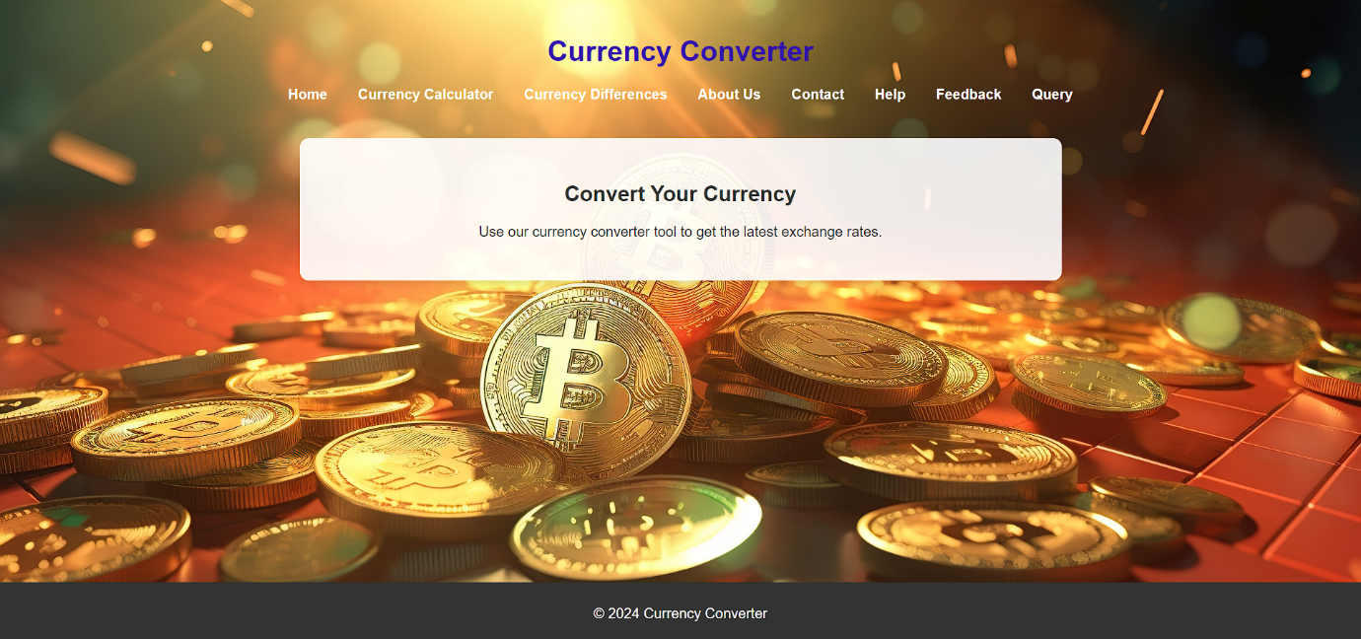

**Currency Calculator page:**

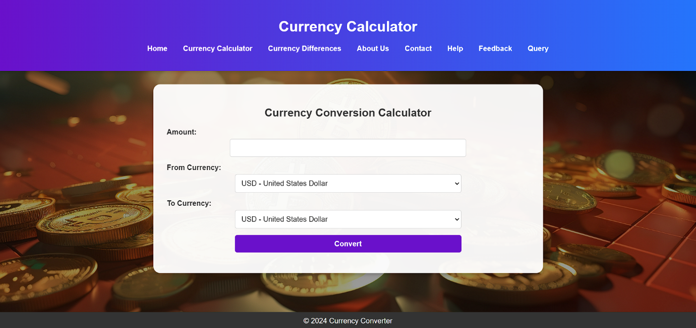

**Concurrency Differences page:**

**\*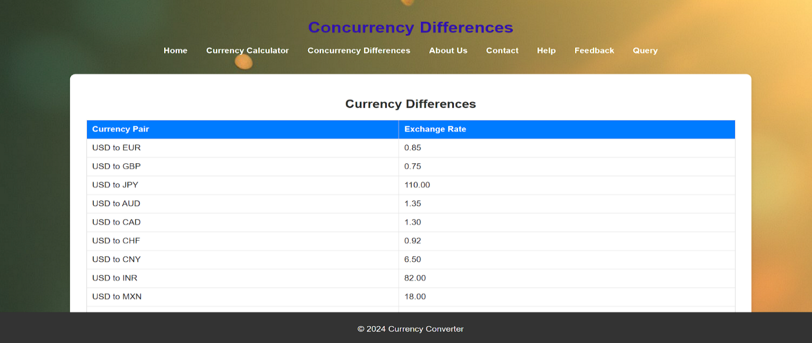**

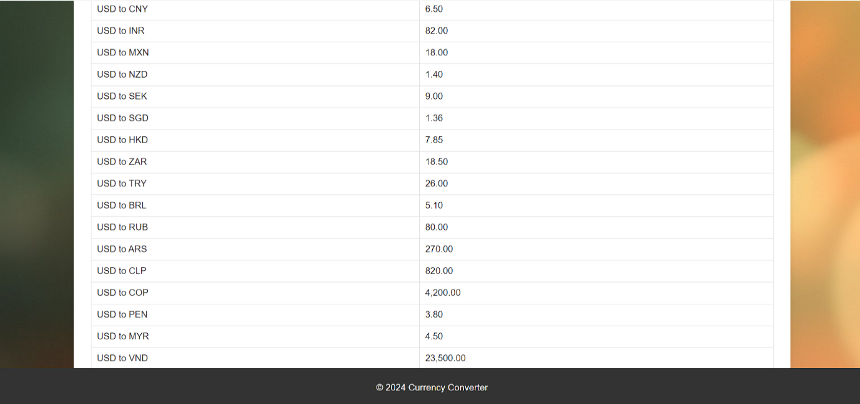

**About us page:**

**9-**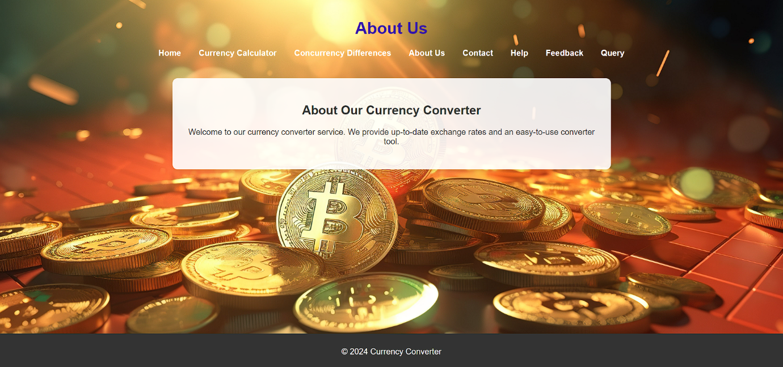

**Contact page:**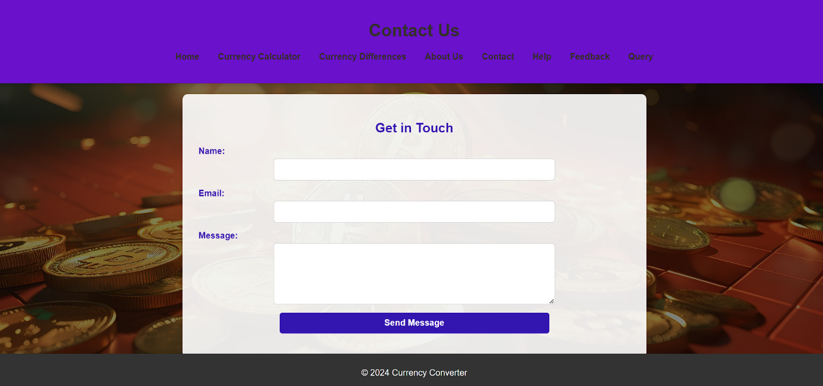

**Help page:**

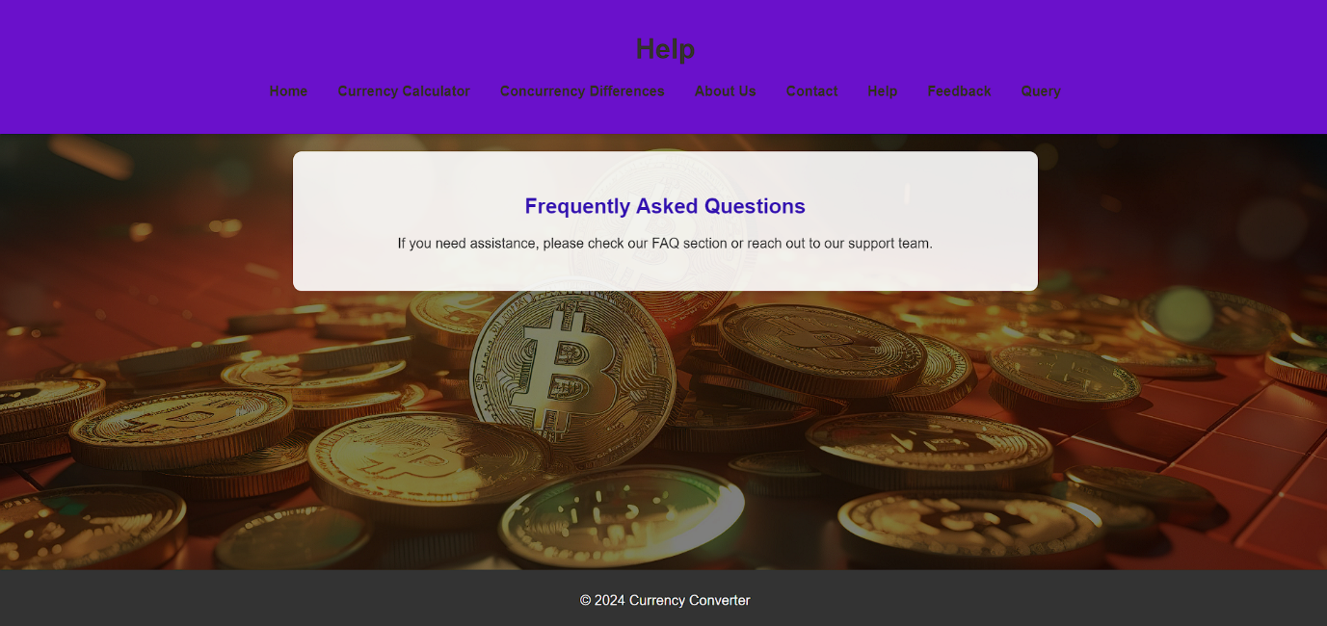

**Feedback page:**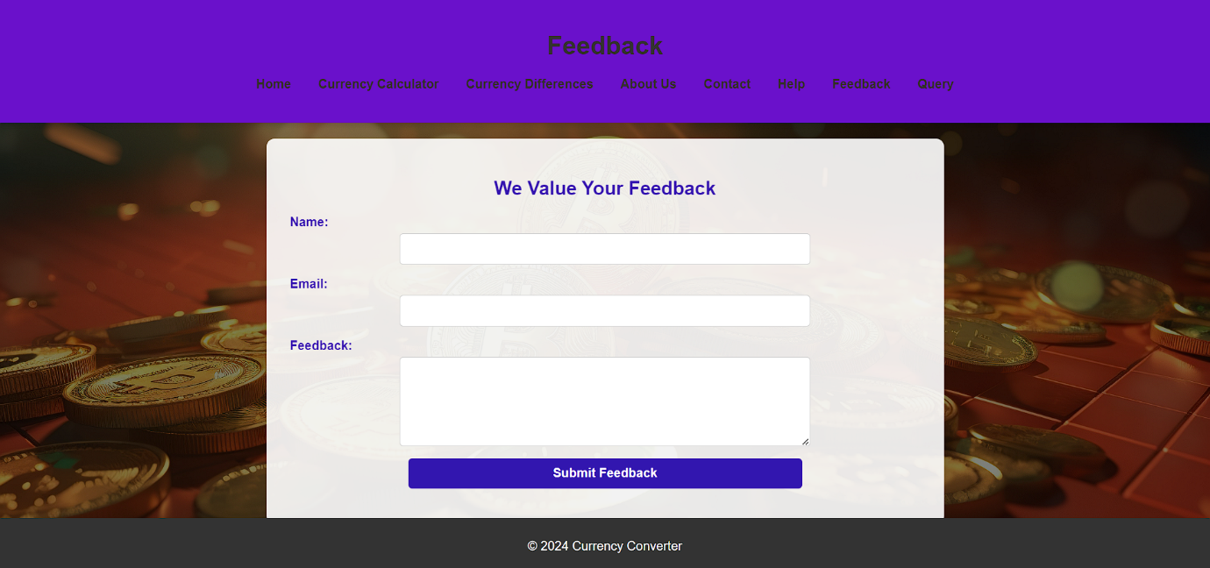

**Query page:**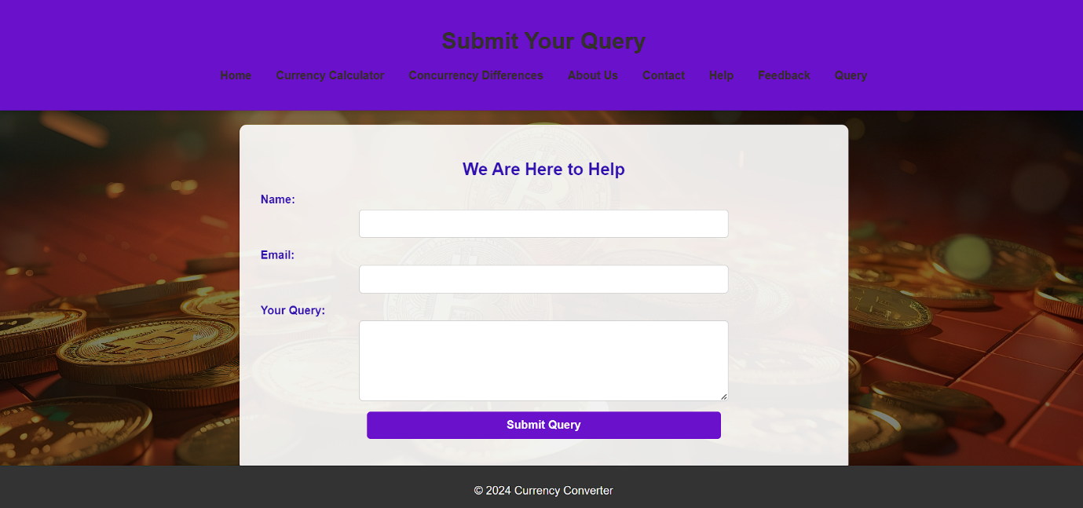

**9.Conclusion and Future Enhancements**

Looking ahead, there are numerous enhancements that can be made to a currency converter application to keep it relevant and increase its functionality. Enhanced data visualization through graphs and interactive dashboards can provide users with a better understanding of currency trends. Machine learning can be employed for predictive analytics, offering insights into future exchange rates and investment recommendations. Integration with financial tools, such as budgeting applications and payment platforms, can add significant value, while expanded currency support, including cryptocurrencies and local currencies, will ensure comprehensive coverage.

A multi-currency wallet feature could enable users to manage balances in various currencies seamlessly. Adding real-time market news and custom alerts can keep users informed about significant currency movements and economic events. Enhanced security features, such as advanced encryption and two-factor authentication, will protect user data, and incorporating localization and accessibility features will cater to a global and diverse audience. Finally, exploring blockchain technology for decentralized exchange rates and utilizing smart contracts for secure and automated processes can position the application at the forefront of financial innovation. Regular updates and user feedback will be crucial in refining and expanding the application's capabilities, ensuring it remains a valuable tool for users worldwide.

## References

1. XE Currency Converter
2. OANDA Currency Converter,
3. Google Currency Converter